**Finding the Best Location for Fast Food**

**Franchise Business at Central Jakarta, Indonesia**

Michael Putra Darmawan

May 20, 2020

1. **Introduction**
   1. **Background**

Fast food business is one of the most profitable food business despite people’s negative mindset on junk foods. Its preparation time convenience and food taste are some of the important factors which sustain this food business. To illustrate, Kentucky Fried Chicken (PT Fast Food Indonesia Tbk) has expanded to all over 100 cities across Indonesia, comprising a total of 493 outlets[1]. In a span of 8 years since 2009, KFC’s revenue went up from 2.5 billion rupiah into 4.8 billion rupiah (almost 100% inclination). Other top Fast Food business around Jakarta includes Mc Donald’s and Burger King. Mc Donald’s, for instance, has emerged as the most valuable fast food chain with a brand value nearing 130.36 billion [USD](https://www.investopedia.com/terms/u/usd.asp) and total assets of 47.5 billion USD.[2]. Thus without any doubts, it will be a good business to franchise on.

* 1. **Problem**

We will explore the vicinity of Central Jakarta City to locate the best possible location candidates to open a fast food franchise business which fulfills the two conditions: no two restaurants in radius of 250 meters and distance to closest fast food restaurants is 600 meters.

1. **Data acquisition and cleaning**

**2.1. Data sources**

This project requires us to utilize Google Maps geocoder API and Foursquare API to obtain the details about the venues around the vicinity. However, as we have already determined the area to be explored, i.e. Central Jakarta, we will proceed by finding the postal codes of sub-districts in Central Jakarta ([link](https://kodepos.nomor.net/_kodepos.php?_i=kota-kodepos&sby=100000&daerah=Provinsi&jobs=DKI%20Jakarta)). From these postal codes, we will be able to determine the coordinates of the sub-districts then integrate it with Foursquare API to acquire the nearby venues around the vicinity.

**2.2. Data cleaning**

As venues are not limited to restaurants, filtering the results to only restaurants will be necessary. Creating a new data frame specific to fast food restaurants is also needed so that the visualization tools, i.e. Folium, can depict which one is fast food restaurants and which one is not. Furthermore, the data cleaning will be based on the important factors to be considered throughout this project:

* number of existing restaurants in the neighborhood (any type of restaurant)
* number of and distance to Fast Food restaurants in the neighborhood, if any
* distance of neighborhood from city center

1. **Exploratory Analysis**

**3.1. Visualizing the towns located in Central Jakarta City**

There are 44 towns belonging to 8 unique sub-districts.

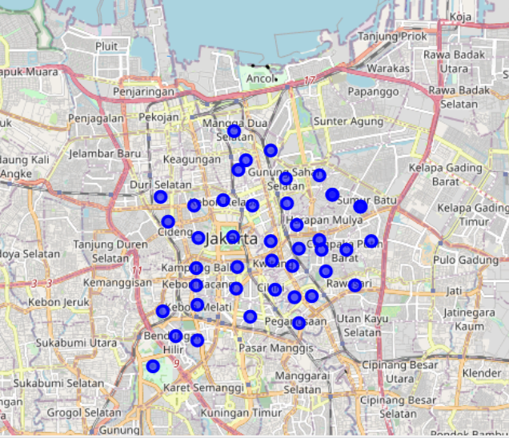

**3.2. Creating and visualizing 364 candidate neighborhood centers**

Hexagonal grid of cells equally spaced from every individual neighbor are created.

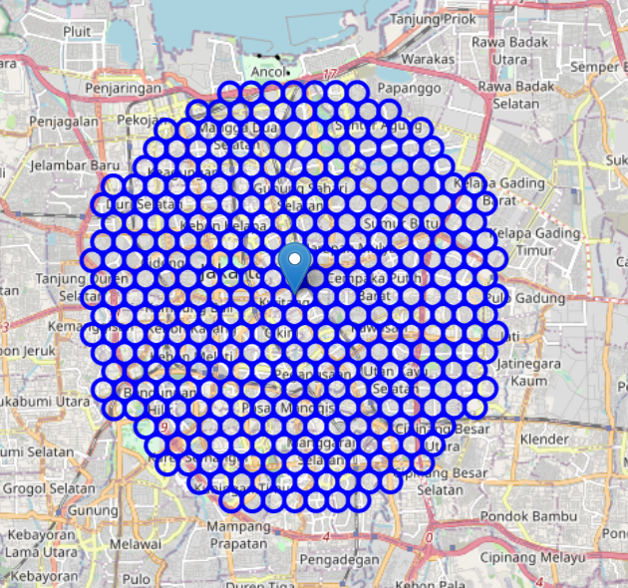

**3.3. Gathering the center coordinates of the hexagonal grids (neighbor center)**

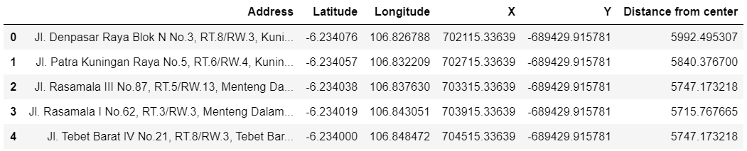

**3.4. Using Foursquare API to get nearby fast food restaurants and count**

**3.5. Visualizing all restaurants and indicating which one is a fast food restaurant in red**

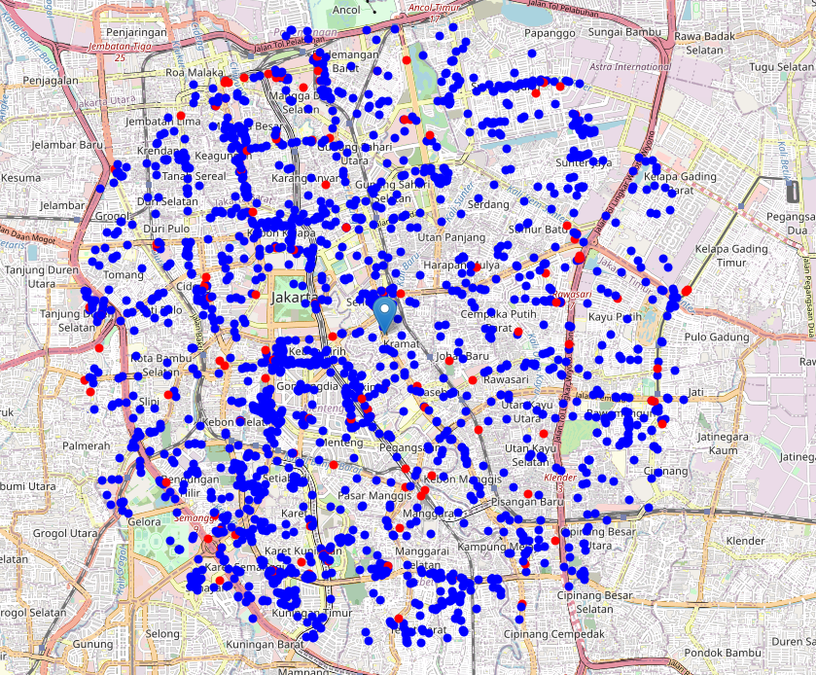

**3.6. Creating a heat map to visualize the density of restaurants in vicinity.**

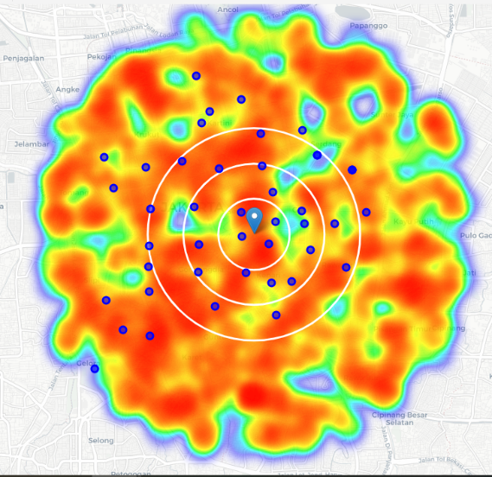 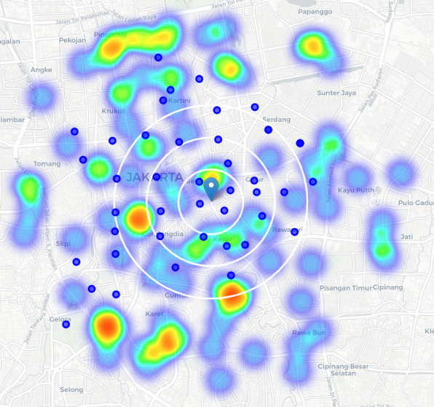

Fig.a.All restaurants included Fig.b. Only fast food restaurants

**3.7. Reducing the scope of search into a radius of 2km.**

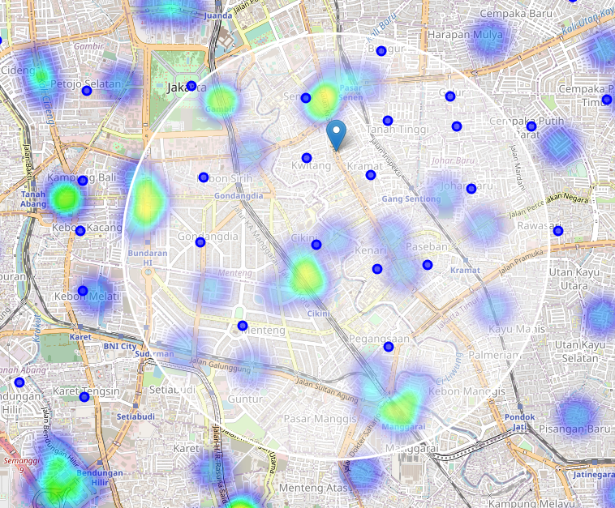

**3.8. Generate new neighbor centers and apply the condition.**

2155 candidate neighbor centers were generated. These candidates will be filtered out by the pre-defined conditions: no two restaurants in radius of 250 meters and distance to closest fast food restaurants is 600 meters.

* Locations with no more than two restaurants nearby: 1181
* Locations with no fast food restaurants within 600m: 454
* Locations satisfying both conditions: 274

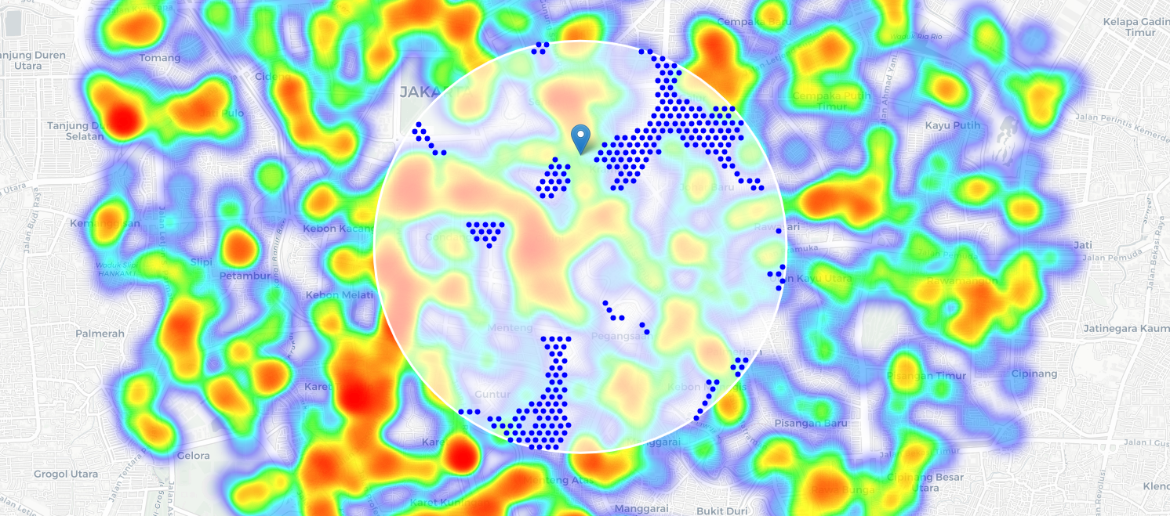

1. **Clustering**

Clustering with k-means will be conducted, with k=15 centroids, to determine the best 15 from 274 candidates. The resulting centroids will be inputted into Google Maps geocoder API in order to obtain the full address of that particular coordinates.

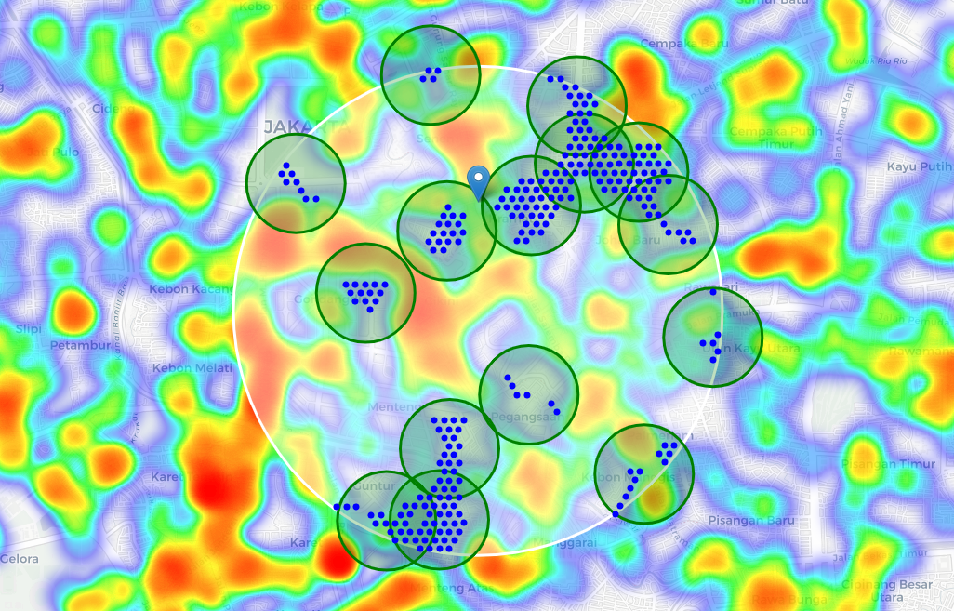

We finally obtain the best 15 locations where both conditions are met.

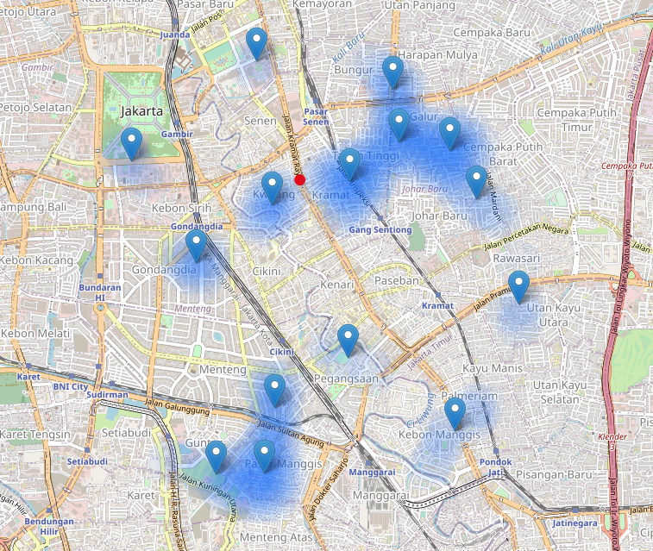

The following table is the list of potential location addresses for the stakeholders to review and decide which location is to be further analyzed in terms of other factors (see Discussion).

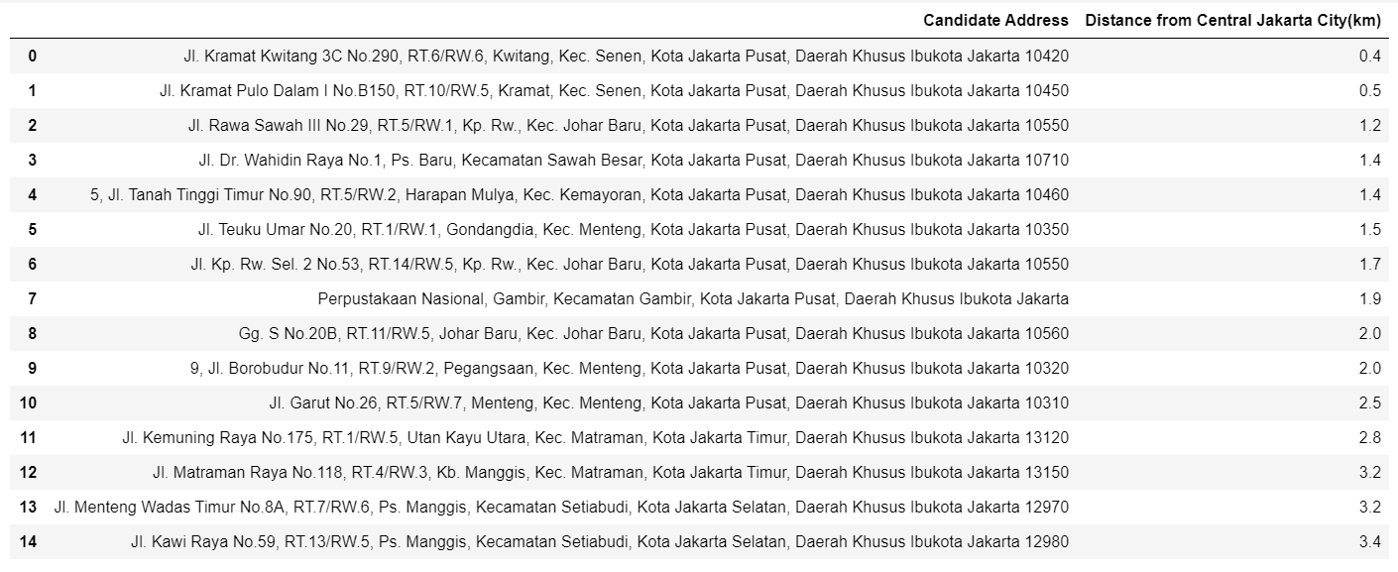

1. **Discussions**

Through this analysis, we are able to locate areas with low-density of restaurants around south, southeast and east of Central Jakarta, despite there are at least 2000 restaurants spreaded across the vicinity. We successfully recognize 15 final locations to be presented to the stakeholders who opt to open a fast food franchise business. The locations are nonetheless are located at the following sub-districts: Senen (2 locations), Johar Baru (3 locations), Menteng (3 locations), Sawah Besar (1 location), Gambir (1 location), Kemayoran (1 location), Setiabudi (2 locations), Matraman (2 locations).

Notice that Setiabudi and Matraman are sub-districts of South Jakarta not Central Jakarta. This is interesting because South Jakarta people are well-known for being more elite in terms of living than the others. And as these locations do meet our pre-defined conditions, these might be other alternatives to consider.

Venue cost wise, we could rank from the most expensive to cheapest as follow: Menteng, Kemayoran > Senen, Johar Baru, Sawah Besar, Gambir > Matraman, Setiabudi. These rankings do make sense as the more central the location is, the more strategic the place is.

The 15 locations above met the requirement of no more than two restaurants in radius of 250 meters, and no fast food restaurants in radius of 600 meters. However, these findings should only be a starting point for further analysis (stage 2) in terms of franchise cost, fixed cost (venue rent including tax), variable costs such as inventories and employee salaries, target consumers, potential revenues, and much more.

The location with the least number of breakeven days should be picked. Another deeper analysis needs to be done until the stakeholders are convinced on the business prospect.

1. **Conclusion**

We have started from a simple postal code of Central Jakarta, retrieve their coordinates, and fetching nearby venues in the vicinity using Foursquare API. We have narrowed down the location candidates by two requirements of low restaurant density. And we have filtered 364 locations to 15 potential locations, which are pending for further technical analysis, using k-means clustering to extract the centre location candidate.

Final decision is on the stakeholders who will take into account many additional factors such as attractiveness of each location (proximity to park or water), levels of noise / proximity to major roads, real estate availability, prices, social and economic dynamics of every neighbourhood etc.

1. **Future Directions**

If the stakeholders are concern of the initial cost of setting up a fast food business in Central Jakarta, there are several other alternatives such as West, East, North and South Jakarta to consider. Yet, this will be an entirely new exploration project.

1. <https://www.indonesia-investments.com/business/indonesian-companies/fast-food-indonesia/item1364>
2. <https://www.investopedia.com/articles/markets/032015/how-mcdonalds-makes-its-money-mcd.asp>